**Project Design Phase-I**

**Proposed Solution Template**

|  |  |
| --- | --- |
| Date | 19 September 2022 |
| Team ID | PNT2022TMID592924 |
| Project Name | MARINE MASTERPIECES: IMAGE CLASSIFICATION OF EXQUISITE SEA CREATURES |
| Maximum Marks | 2 Marks |

**Proposed Solution Template:**

Project team shall fill the following information in proposed solution template.

|  |  |  |
| --- | --- | --- |
| **S.No.** | **Parameter** | **Description** |
| 1. | Problem Statement (Problem to be solved) | Marine animals are an integral part of the ecosystem.  Knowledge about them , how endangered are they and the importance of preserving them should be taught from a very young age . |
| 2. | Idea / Solution description | The web application based on the CNN model for identifying various marine animals will help kids know and be in awe of the diversity of marine life, motivating them to focus on preserving it. |
| 3. | Novelty / Uniqueness | A fun and interactive approach based on the use of CNNs for identification of marine animals thus helping kids garner a wide knowledge about the variety of marine life and the beauty of that diversity. |
| 4. | Social Impact / Customer Satisfaction | An informative and fun way to teach students about the importance of marine life would help them grow into individuals who are concerned and protective about nature . This will help them develop a conscience for caring and looking after earth and protecting all species |
| 5. | Business Model (Revenue Model) | The core business revolves around the  development, licensing, and sale of web apps and software based on automated identification of sea animals . |
| 6. | Scalability of the Solution | Many applications of this technology can be used for various uses. The identification of various marine life can be used for spreading awareness , for scientific purposes , for teaching through various web apps based on it , thus providing a solution that can be used widely according to one's need. |

**Project Design Phase-I**

**Solution Architecture**

|  |
| --- |
| Date 12 September 2023 |
| Team ID PNT2022TMID592924 |
| Project Name MARINE MASTERPIECES: IMAGE CLASSIFICATION OF EXQUISITE SEA CREATURES |
| Maximum Marks 4 Marks |

**Solution Architecture:**

Identification of various sea animals using CNNs for real time image based identification.

Not only helps in identification but also provides you various links about the endangerment of those sea animals thus spreading awareness.

My solution leverages CNNs to address this problem effectively

* Images of various species gathered
* Image preprocessing
* Model building
* Identification of the animal

**Solution Architecture Diagram**

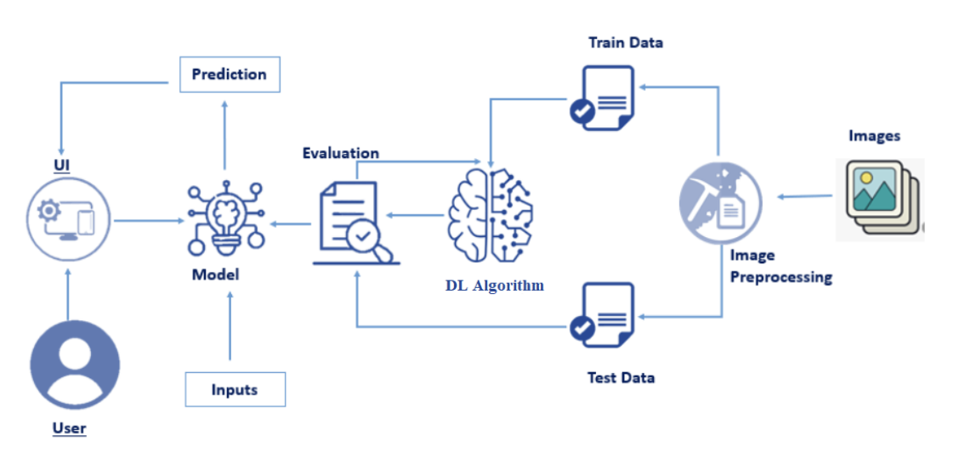

Identification of various sea animals using CNNs for real time image based identification.

Not only helps in identification but also provides you various links about the endangerment of those sea animals thus spreading awareness.

My solution leverages CNNs to address this problem effectively

* Images of various species gathered
* Image preprocessing
* Model building
* Identification of the animal

**Solution Architecture Diagram**

